City of Berlin

Memo
To: Berlin City Council
From: Jim Wheeler, City Manager
Date: 10/05/2015
Re: City Manager’s Report

- The City of Berlin will have a space at the Recreation Department’s Fall Yard Sale on October 24 with all proceeds to benefit RESPONSE and the No More campaign. Donations of quality merchandise will be appreciated and may be dropped off at Berlin Recreation. The City Department Heads raised $302 for RESPONSE over the weekend that the BHS Homecoming games.

During the month of October, we are posting photographs of people holding the “NO MORE” statement and the City’s Facebook page and on the web site. If anyone from the Council would like to make a statement, either individually or collectively, attached is a statement sign.

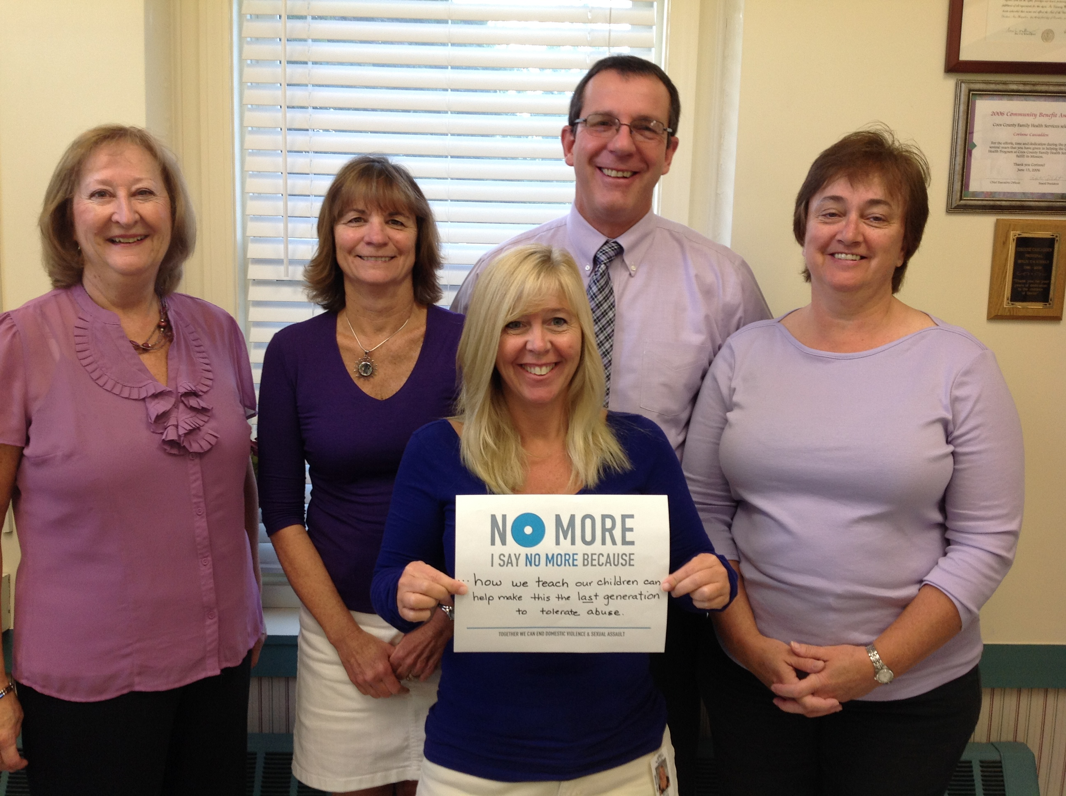

- On Wednesday, September 30 there were approximately 30 abutters to the Route 16 project who met at City Hall to hear an overview of the project plans and they had an opportunity to ask questions. There will be a follow up meeting Wednesday, October 7 from 5:00 to 7:00 p.m. in the City Hall Auditorium

- Citizens Academy
The community will be able to visit Public Works on Wednesday October 14, 2015 from 6:00 to 8:00 PM. The evening will include time for questions with staff as well as a tour of the facility. The Police Department will hold its session on Wednesday October 21st at the Berlin Recreation Center and will also include a tour of the Police Department next door. The series will wrap up with City Council hosting the last evening on Wednesday October 28, 2015 at City Hall and include opportunities for residents to come in and speak individually with the Mayor and Council.

A community forum hosted by the Police Department will be held on Wednesday November 18th, 2015 and will also be held at the Recreation Department. This forum will feature a panel of speakers who frequently interact with addiction and substance abuse in the community and allow for plenty of time for the public to engage directly with panel participants. More details about this forum will be available in mid-October.

- Congresswoman Annie Kuster is hosting a Rail Summit in Nashua on Monday, October 19 from 1:00 to 4:00. A flyer with registration information is attached.

- North Country Council is hosting a meeting about transportation in the North Country on Tuesday, October 20 at Berlin City Hall from 4:00 p.m. to 5:30 p.m. An agenda is attached.

- The final Legislative Bulletin was issued on September 29. It includes all of the changes made in the last legislative session. It can be found at https://www.nhmunicipal.org/Resources/LegislativeBulletin/91 or upon request, we can make a copy for you.

- The bid package for the sale of 99 Pine Island Avenue is out with bids due October 22. The bid package is on the city’s web site.

- Public Works received bids on October 1, 2015 for paving several streets including Cates Hill Road. Bids were as follows:

Morency Paving $85,375.10 (included labor only)
Pike Industries $188,750.00
Central Paving $193,500.00

The work will be performed by Pike Industries. They are currently working on a paving schedule for their work.

- Congratulations to Bryan Chevarie who will be taking on the Assessor Supervisor/Deputy Clerk position. Bryan is currently working the Code Department and begin training in Assessing this week.

