North Country
Bowling Center
Cosmic Bowling
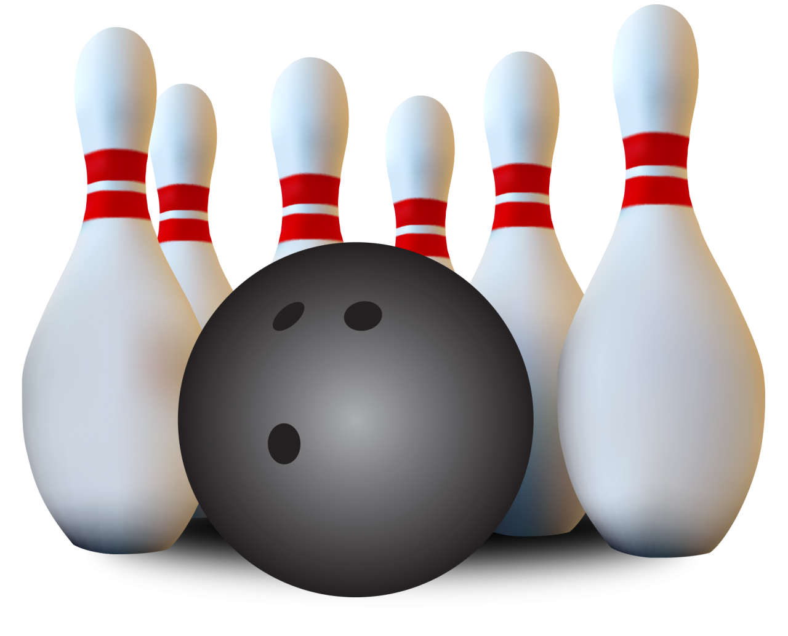
11AM-1PM | APR 26TH  Bowling will take place at 283 Main St. Berlin NH, 03570 can call at (603) 752 - 5250  Sign ups will be at the rec or the bowling alley, can call us at (603) 752 -2010 or email at djohnson@berlinnh.gov
Get your bowling shoes ready and sign up here at the recreation department or the bowling alley for a fun afternoon of bowling! Pizza and ice cream included.
$12.00 for kids 10 and under
$14.00 for kids 11 and up

