Berlin Recreation Department
Summer Program 2023
Join us this summer for some fun in the sun! Monday - Friday we will have sports, games, and themed crafts! Field trips will include local hiking and trips to Whales Tales, Jericho Lake, Maine Wildlife Park, and much more.
The daily park program is FREE at all parks and the recreation department. Must be at least 4 years old otherwise accompanied by an adult.
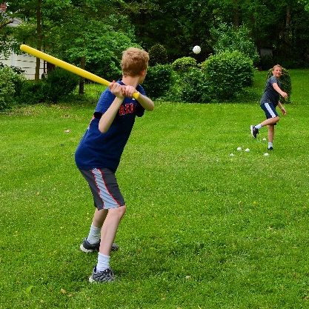
Field trips will have a $125 fee for bus fare. Entrance fees to field trips will also need to be paid prior to boarding the bus. Kids who sign up MUST be at least 7 years or older to participate on field trips.

When: Starting June 19th from 10:00AM to 3:00PM.
Where: Community Park, Brookside, and the recreation department.
Cost: FREE registration for parks and $125.00 for the bus rides (note: field trip cost not included).
Age:4-6 for parks and ages 7 and up allowed on field trips
Attire: weather appropriate attire, sneakers with socks (sandals for lake days is okay), water bottle, and sunscreen.
Registration is at the berlin recreation department please call at (603)752-2010 or come in we are located at 672 First Ave.
https://www.facebook.com/berlinrecreationcenter
Follow us!

