Berlin Recreation Annual Report July 01, 2016 – June 30, 2017

Services provided by the Berlin Recreation Department throughout this fiscal year remained numerous and varied. Unfortunately, space does not allow acknowledging all activities and the devoted staff and volunteers who made our events possible. Programs described below either were new and/or expanded during fiscal year 2017.
Please call 752-2010 or visit Recreation’s Publicity section at
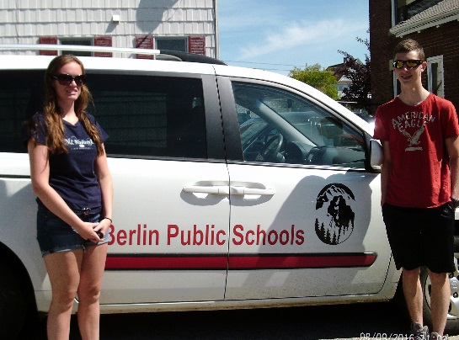
www.berlinnh.gov for the very latest in what is taking place now!

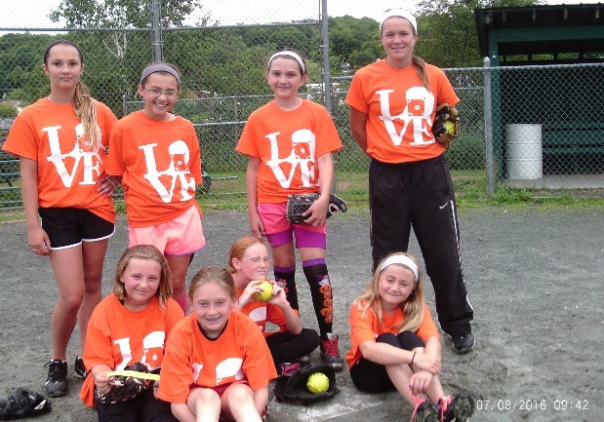
In the summer of 2016, Berlin Recreation served 1,553 lunches and 1,399 snacks to area children who visited the Recreation’s four playground sites in addition to serving Project Youth’s programs at Hillside Elementary and St. Barnabas. This was the first year Berlin Recreation provided food to Project Youth which increased the meal demand substantially. The Berlin School Department generously granted Recreation the use of a Public School van making it possible to execute the delivery of such a large number of bagged lunches and snacks efficiently. We are truly grateful to the Berlin School Department for this collaboration. Summer personnel Morgan Boucher & Noah Dumas stand ready to deliver
For one week in July, meals. (Staff photo)
Ms. Whitney Roberts, a former
Plymouth State softball player, created a Softball Camp for young
ladies ages 9 – 15. After days of being taught the fundamentals,
a fun scrimmage game was held concluding with each girl receiving
a complimentary t-shirt. The girls certainly benefited from such a
talented instructor!

Instructor Whitney Roberts with “her team”
(Staff photo)

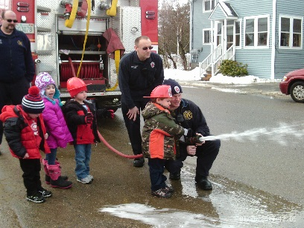
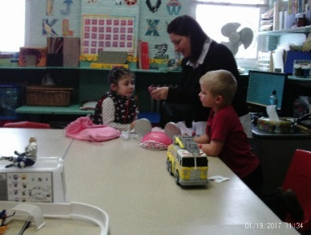
Ms. Missy Wedge came on board as Recreation’s new Assistant in November, 2016. “Miss Missy” quickly reinstated the Little Tykes Playground program introducing Show and Tell and inviting other city departments such as the Fire Department to visit with the young children.

Show & Tell Time with Little Tykes Taking turns holding the
Playground children fire hose. (Staff photo)
(Staff photo)

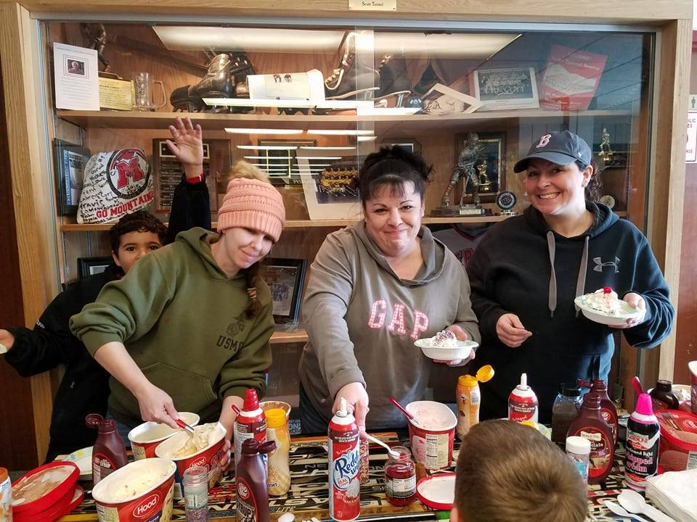
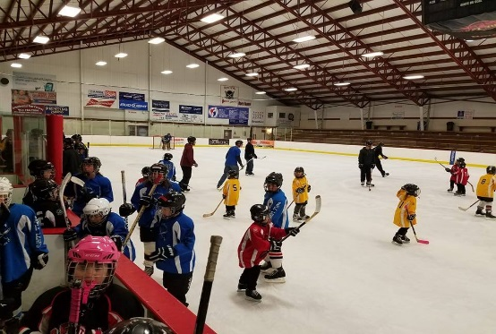

Missy’s enthusiasm extended to the Recreational Hockey Development League. With Missy’s husband Mike and their recruitment of other qualified volunteers, participation in Recreation hockey continues to grow. Their energy and teaching skills are providing a quality
Recreational Hockey Open Skate Event hockey experience for Sara Poirier, Amanda Reed, & Missy Wedge
(Staff photo) every skating level. serving treats at the End of Season
Hockey Party. (Maya Wedge photo)
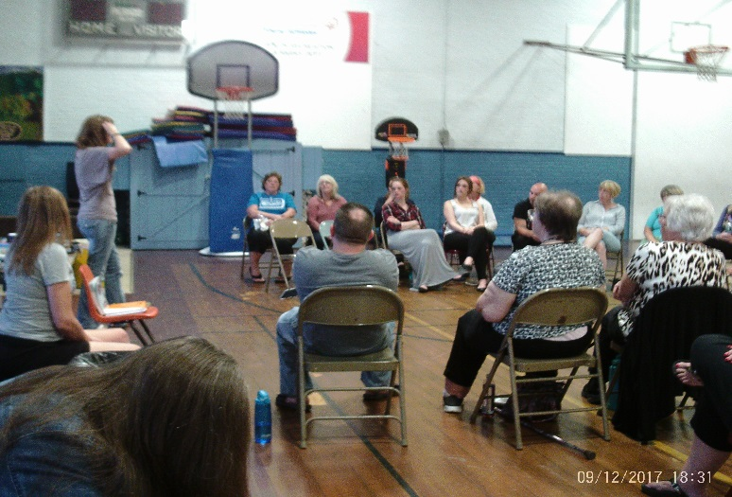
Mrs. Vicky Arsenault started teaching Tai Chi Quan – Movement for Better Balance in the fall of 2016. A group of senior citizens joined her twice a week at the Berlin Recreation Center for low impact stretching exercises. The seniors’ goal was to improve their balance as they monitored their progress throughout the sessions.

Mrs. Arsenault also facilitates Health & Hope Nights – an informal monthly gathering where residents of all ages share healthy recipes, dieting tips, and general inspirational stories for leading a positive life. All this and tasty, nutritional snacks too!
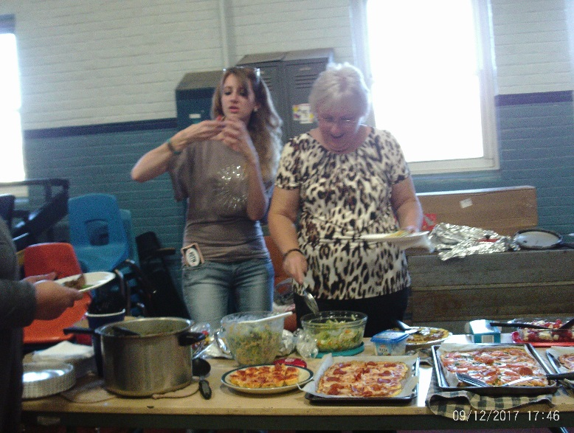
Health & Hope Night monthly gathering (Staff photo)

Members enjoying the plentiful snacks
at Health & Hope Night. (Staff photo)

As always, Berlin Recreation welcomes any opportunity to offer new programs in our effort to remain a vibrant member of the community. Do not hesitate to contact us if you have an idea to share.
Sincerely,
Terry Letarte, Program Director
Berlin Recreation Department

