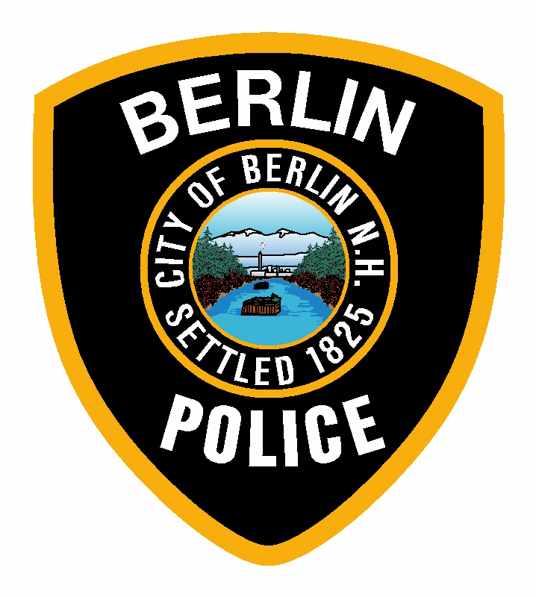

BERLIN POLICE DEPARTMENT PATCH ORDER FORM

NAME: _____________________________________________________________

STREET ADDRESS: __________________________________________________

CITY/STATE/ZIP: ____________________________________________________

Quantity of Patches: _______________ X $5.00 ea. = _________________________

Please enclose this completed order form along with American money order or American currently only (personal checks will not be accepted), and mail it to:

Berlin Police Department
135 Green Street
Berlin, NH 03570

